**Defect Report for Nykaa.com**

**Defect** **id :** NYKAA_B_001

**Defect** **Name :** Download Link

**Module** **name :** homepage

**Severity**  **:** High

**Priority :** High

**Summary / Objective :** The defect concerns the user is able to get app download link via SMS

**Steps to reproduce / Description :**

Pre- requisite:

Login into nykaa.com

Steps to reproduce:

1.Open Nykaa.com

2.Navigate to “Get App”

3.enter any phone number(registered or not registered)

4.click on captcha

5.click on “send link” button

**Actual Result:**

User is not able to get link via SMS on entered phone no.

**Expected Result :**

User should get link via SMS on entered phone no.

“SMS sent” display on screen but not receiving any SMS to user.

**Note/observations:**

1. Please refer the attached screenshot

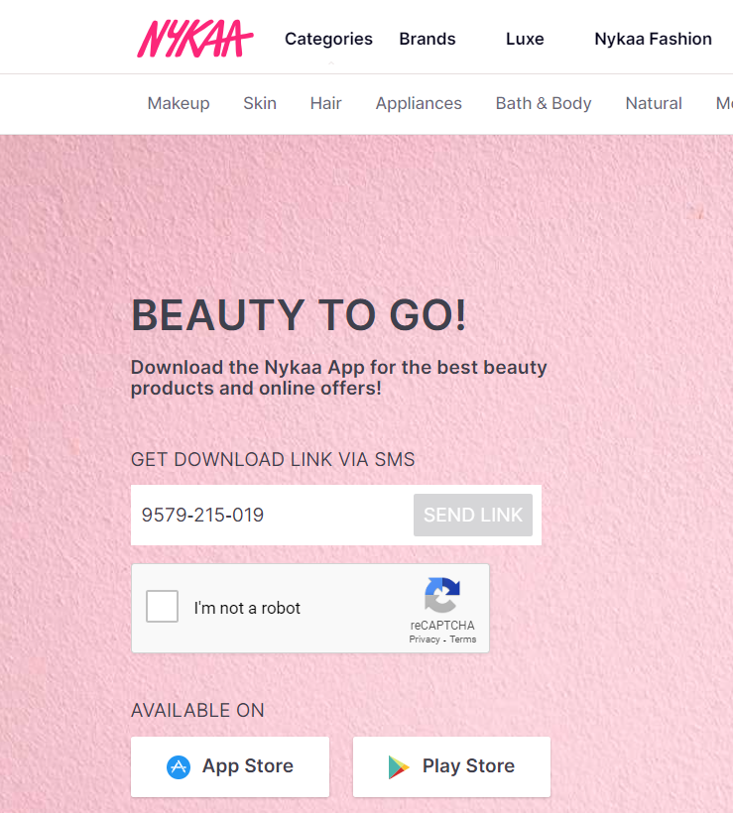

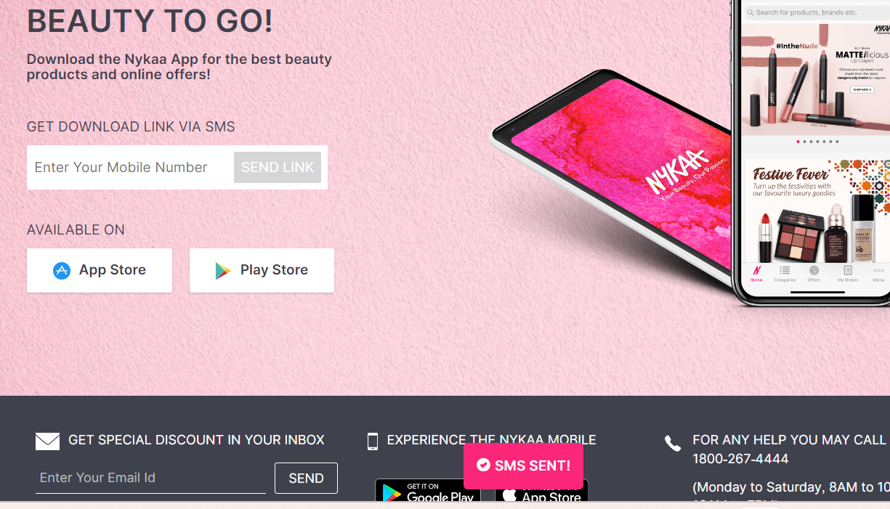

**Reported By**: Saylee Raut

**Date**: February 17,2024